INTRODUCTION

1. **User requirement**
2. **State of the art**
3. **Facial Recognition**

The challenge of face recognition can be formulated as followed : with one or several images of a face, the goal would be to find or check the identity of a person by comparing his face to all the face images stored in a database. It is the most common and even popular skill. By the way this skill remains the most acceptable because it more suits with what human beings use in visual interaction; and compared to other methods, the face recognition seems more advantageous, in fact it is a non-intrusive method, in other words it does not require the cooperation of the subject, and a moreover the sensors used are cheaper.

* 1. **Facial recognition process**

Any facial recognition process must take into consideration several factors that contribute to the complexity of its task, because a face is a dynamic entity which constantly changes under the influence of several factors. A facial recognition system is generally divided into the following steps (see the figure):

Humans faces

Image capture

Extraction characters

Statistical analysis

Learning

Decision and classification

Facial recognition is facing the following problems:

* Change of pose
* Illumination Variations
* Variations of expression, age
* Partial occultation of the face

These variations are the most difficult because the variations in the appearance of a person face according to different pose or light conditions are often far more important than the variation between face images of two different individuals acquired under the same conditions.

This explains why pictures should be taken in specific conditions so that facial recognition can be efficient.

* 1. **The methods used for face recognition**

Facial recognition methods can be classified into two broad categories: local and global methods. Amongst those methods, main ones will be presented thereafter.

* + 1. **Global methods**

Global methods are based on well known techniques of statistical analysis. In these methods, face images (which can be shown as matrices of pixel values) are used as input of the recognition algorithm and are generally transformed into vectors, which are easier to handle. The main advantage of global methods is that they are relatively quick to set up in. However, they are very sensitive to variations of illumination, pose and facial expression.

The main existing methods are:

The principal Component Analysis (PCA) : **EigenFaces**

The algorithm LDA (Linear Discriminant Analysis) : **FisherFaces**

* + 1. **Local methods (Geometric)**

The local methods include transformations applying to specific areas of the image, usually around characteristic points (corners of the eyes, mouth, nose, ...). Therefore, they require a priori knowledge on images. These methods are more difficult to implement but are more robust to the problems due to variations of illumination, pose and facial expression. The main existing methods are:

EBGM (Elastic Bunch Graph Matching);

Modular Eigenface;

Hidden Markov method.

1. **EigenFaces**
2. **FisherFaces**

Eigenface method uses PCA for dimensionality reduction, which yields projection directions that maximize the total scatter across all classes of images. This projection is best for reconstruction of images from a low dimensional basis. However, this method doesn’t make use of between-class scatter. The projection may not be optimal from discrimination for different classes.

While this is clearly a powerful way to represent data, it does not consider any classes and so a lot of discriminative information may be lost when throwing components away.

The Fisherface method is an enhancement of the Eigenface method that it uses Fisher’s Linear Discriminant Analysis (FLDA or LDA) for the dimensionality reduction. The LDA maximizes the ratio of between-class scatter to that of within-class scatter, therefore, it works better than PCA for purpose of discrimination. The Fisherface is especially useful when facial images have large variations in illumination and facial expression.

This projection maximizes the ratio of between-class scatter to that of within-class scatter. The idea is that it tries to “shape” the scatter in order to make it more reliable for classification.

* 1. **Linear Discriminant Analysis (LDA)**

The Linear discriminant analysis (LDA) is used to find the linear combination of characteristics that separate the best object classes or events. The resulting combinations can be used as a linear classifier, or generally in reducing characteristics before the posterior classification.

LDA is closely related to the CPA, because both seek the linear combinations of the variables that best represents the data. It explicitly test to model the difference between data classes unlike the ACP that does not take into account the differences between classes.

* 1. **LDA for recognition**

The LDA by recognition algorithm is divided into two phases, one for the calculation of models that people call the system learning phase and the other is to recognize that a person tests compared to models that registered call stage tests.

* + 1. **learning phase**

As in the PCA, it gathers the images of the learning base in a large image matrix where each column represents a Ti image, then the average image is calculated.

For each class C, the average image is calculated.

Each image Ti of each class Ci is then refocused in the average. This produces a new image.

Then they move to the calculation of different dispersion matrixes:

* The Intra-class Distribution Matrix;
* The Inter-class Distribution Matrix;
* Total dispersion matrix.

After we have defined the different dispersion matrixes, we must find the best projection that maximizes the intra-class dispersion on its matrix while minimizing inter-class dispersion, also on its matrix.

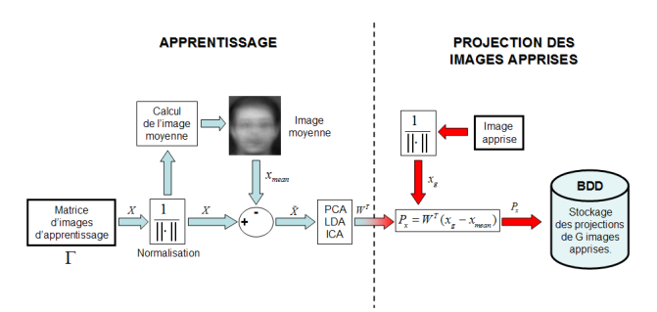

Fig : Learning phase of a face recognition system using a global method

* + 1. **tests phase**

Once the optimal projection that maximizes found intraclass dispersion, the same pattern as the PCA on the projection of learned image and the projection of a test image is applied.

Then we project the test image in the Fisher space

We compare the models obtained in learning. The comparison is made by calculating the distances between models and the test vectors and a decision rule is used to classify people. For example, calculation of the Euclidean distance.

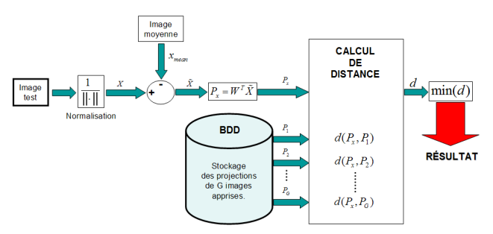

Fig : Test phase of a face recognition system using a global method

* 1. **Benefits and deficiencies**

Using the LDA method for face recognition, we have the following advantages:

* maximizing inter-class scatter ;
* Reduction of intra-class scatter ;
* The method of Fisherfaces solves the problem of robustness to changes in pose, and facial expressions.

Despite these advantages, in the literature a series of negative spikes still exists as:

* costly in computation time ;
* costly in memory space ;
* Makes poor results when the number of training images is great.

1. Project implementation
2. EigenFaces prototyping
3. FisherFaces prototyping
4. Guideline manual
5. Project management

CONCLUSION